**1. Download community version PyCharm**

http://www.jetbrains.com/pycharm/download/#section=windows

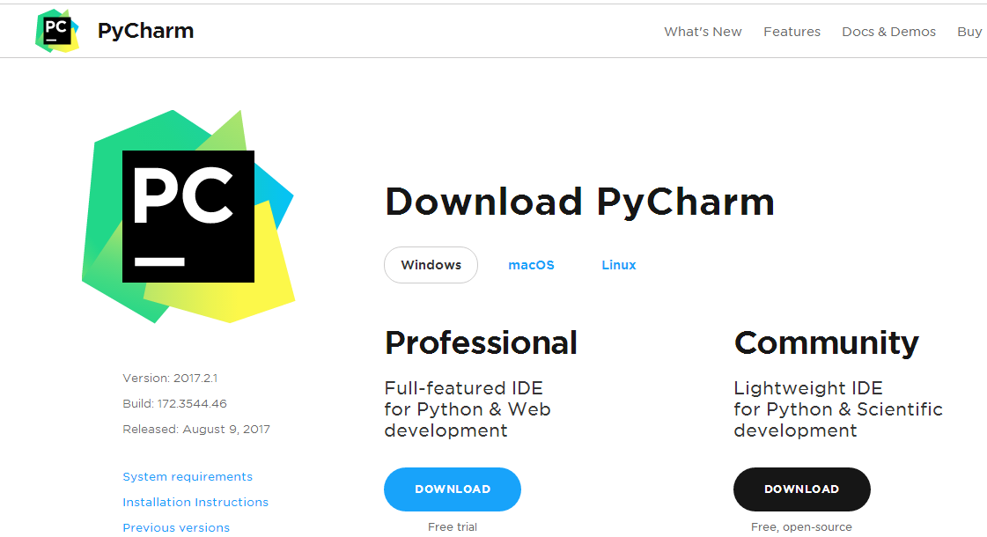

**notice:**

when you are installing, you can select keymap as you like.

here I selected like "Eclipse".

**Keymap：**

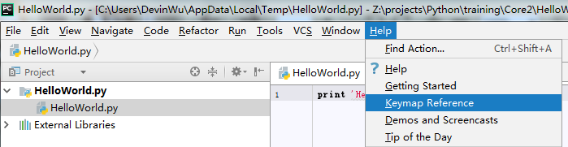

**2. Install Vim plug-in**

**2.1 Online**

Step1： File---Settings

Step2： Install JetBrains Plugin

Step3： IdeaVim

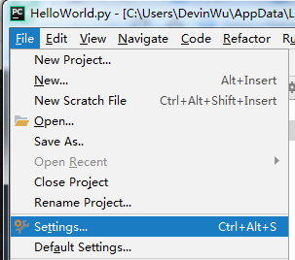

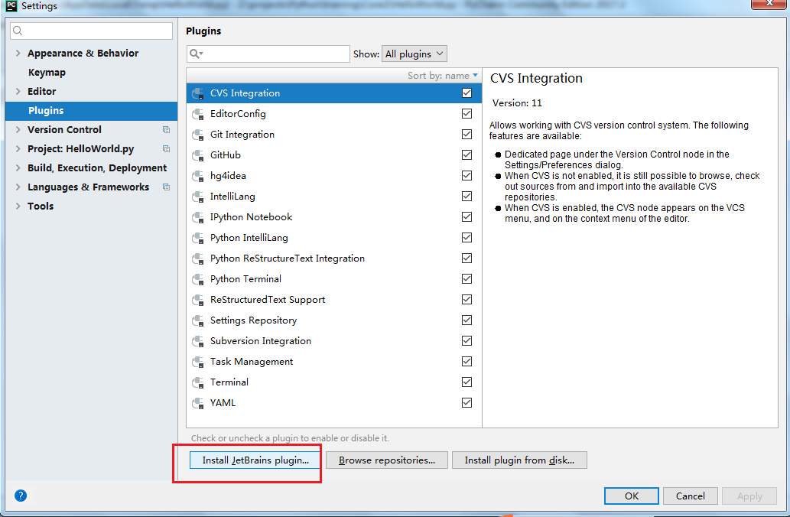

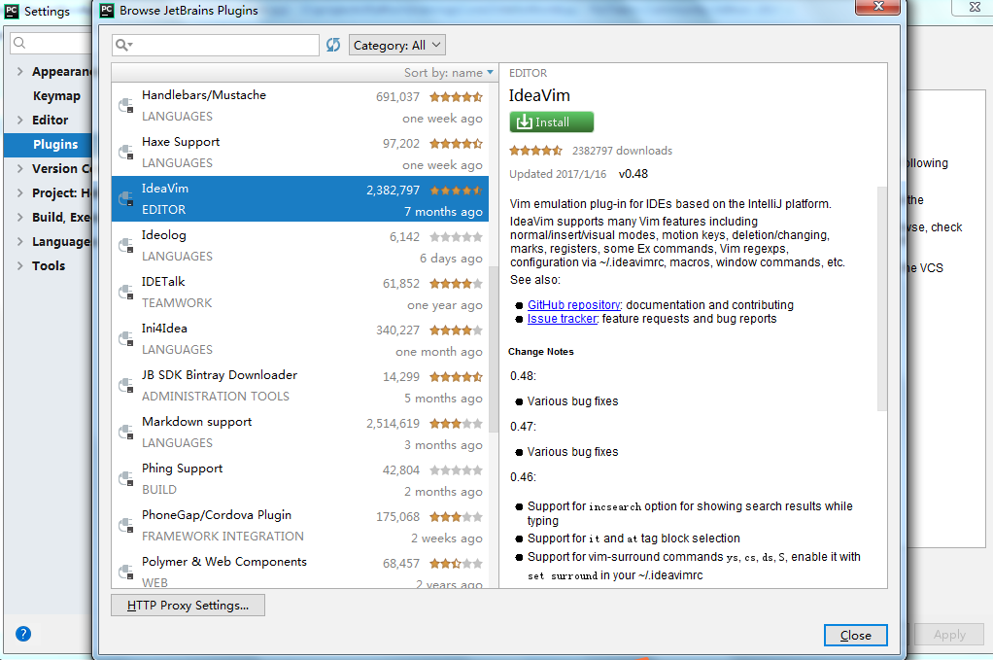

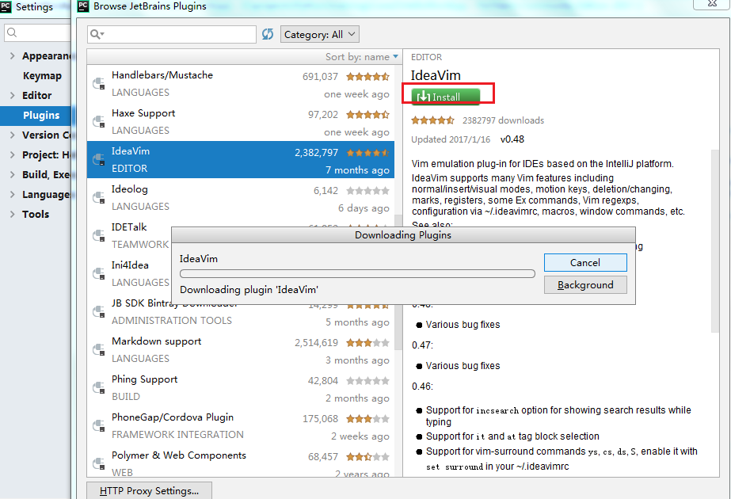

**2.2 Offline**

**step 1: you need download ideavim.**

https://plugins.jetbrains.com/plugin/164-ideavim

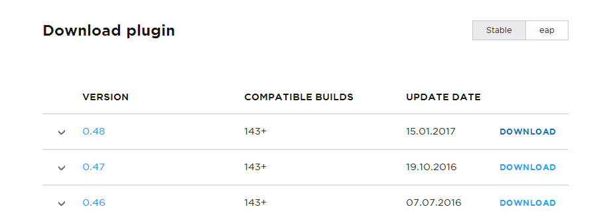

https://download.plugins.jetbrains.com/164/31805/IdeaVim-0.48.zip?updateId=31805&pluginId=164



**step2: import it**

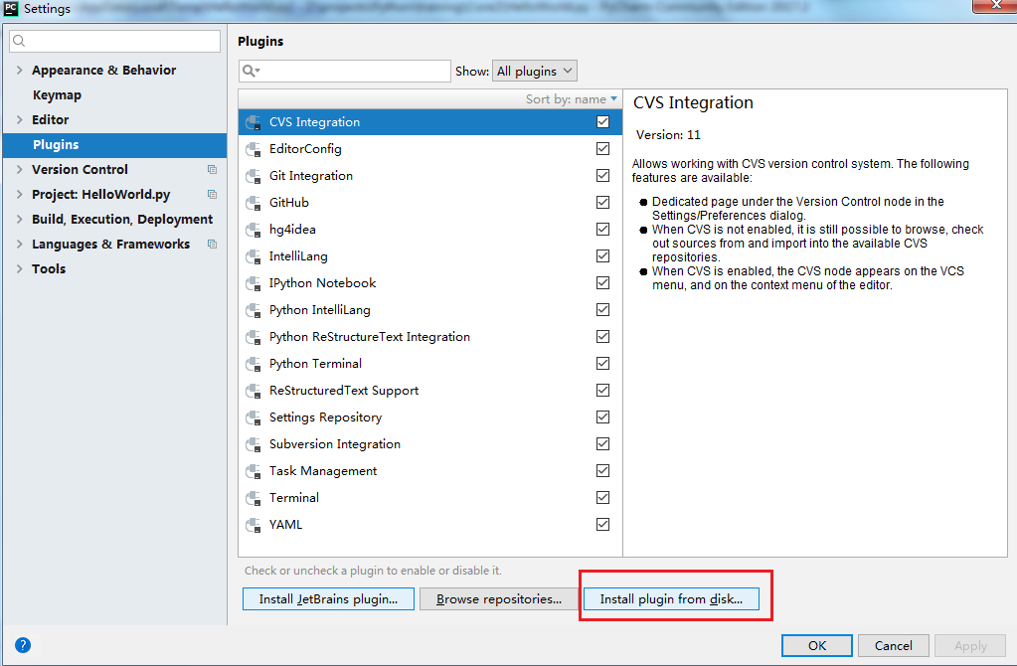

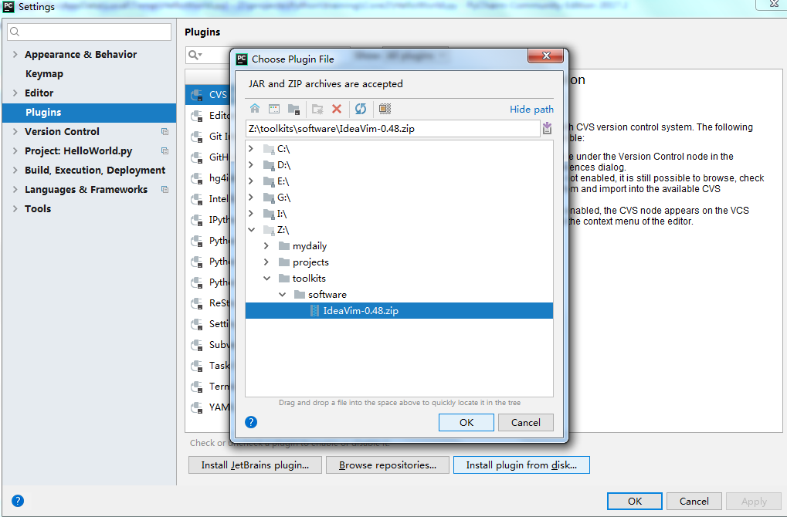

apply it and click ok

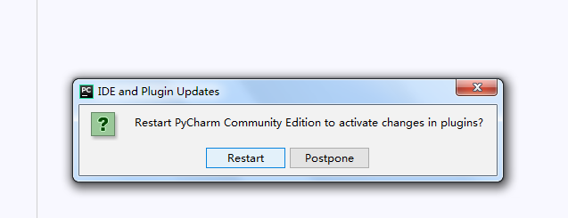

so restart PyCharm

then you can use vim commands.